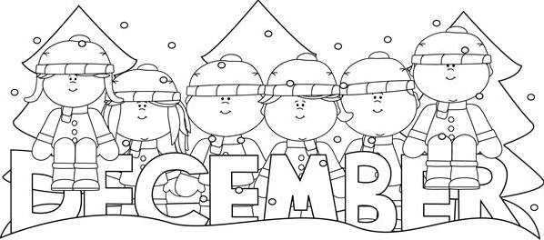
December Homework - Kindergarten
Name_____________________
Due: Monday, January 7th

*I can count to ____ without help or mistakes!

*How many sight words can you read in your folder? ______ Words. Pick 5 words your child does not know, and practice them as often as possible. As they learn the words add new unknown words.

*Write the numbers from 0 to as high as you can. I wrote my numbers to _____.
*Practice tying your shoes
*Read a story to your child and have them retell it with details – beginning-middle-end.

*Color the numbers that your child can name quickly without help.
0 | 3 | 6 | 9 | 12 | 15 | 18 | 1 | 4 | 7
10 | 13 | 16 | 19 | 2 | 5 | 8 | 11 | 14 | 17

Have your child read the following words by using the letter sounds to figure them out if necessary.
cub | bat | top | pen | dad | bug | dot | lip | so | wig

Read a story to your child without showing them the pictures, ask them to draw a picture to go with the story. Then have them write a sentence about what their picture shows.
*Time yourself and see if you can get your snow gear on in 3 minutes without help! _____ I did it! ______ I will keep practicing.

*Color the sight words your child can read quickly without any help.
a | me | the | I | like | my | at | look | see | here
is | find | an | in | it | and | dad | now | mom | are

*Have your child say the next three numbers for 10… 6… 15… 21… 39…
_____ I got them all! _____We will keep practicing.
*Write numbers from 1-30

Enjoy family time! Due: Monday, January 7th
Read for 20 minutes each day and initial the date below. If you read and sign 25 of the 31 days your child will earn a free personal pizza from Pizza Hut.
