Kindergarten November Homework Student’s Name _____________________________
Parent’s Name _____________________________
Due: Monday, December 3rd

Circle the letters that your child can make the sounds for.
T V R G Th E I Th X S N D M Q L Y
Ch C U J O H B Z W P K F A Sh
Can your student count-back from 20? _______ If not keep practicing!

Make a list of 3 things you are thankful for.

- ________________________________________________________________________________________

- ________________________________________________________________________________________

- ________________________________________________________________________________________

Color the words your child can read quickly and easily without help. Be sure to study the words that your child missed so they know them by the end of the month.
see | I | the | dad | like
a | it | and | me | house
my | is | in | an | this
mom | park | at | look | here

Measure five things in your home. What is the tallest? Which is the shortest?

_____________________________________ _____________________________________

Write you’re first and last name 3 times.

______________________________________________________________________________________________

______________________________________________________________________________________________

______________________________________________________________________________________________

How high can you count? ____________

Cut letters out of the newspaper or a magazine and make your sight words.

Read a story and ask your child to retell the story. Did they tell the beginning, middle and end of the story? _________
Was it simple and basic or was it detailed and descriptive? _____________________________________

Label the pictures that are part of the -an word family.
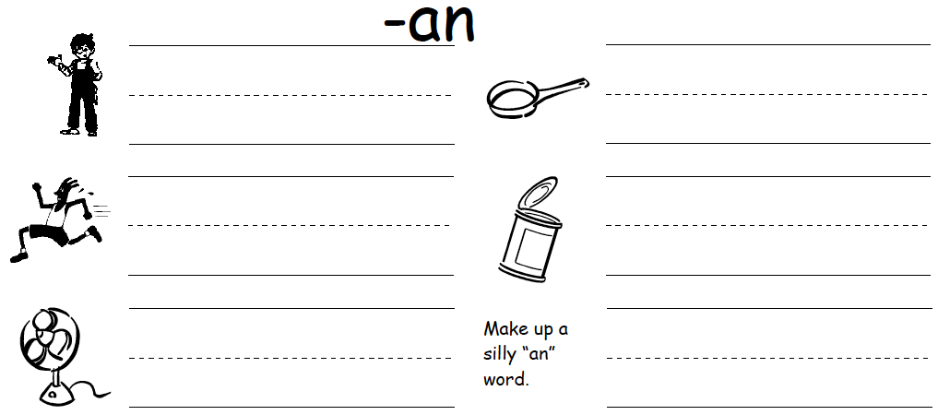

Circle the numbers your child can read quickly and easily without help.

20 11 9 16 3 19 14 17 5 7 2 15
8 10 16 4 1 0 12 13 6 18 13

Write numbers from 1-20 - No reversals please!

Initial each day you read with your child for 20 minutes or more.
November Reading Minutes
Sunday | Monday | Tuesday | Wednesday | Thursday | Friday | Saturday
 |  |  |  | 1 | 2 | 3
4 | 5 | 6 | 7 | 8 | 9 | 10
11 | 12 | 13 | 14 | 15 | 16 | 17
18 | 19 | 20 | 21 | 22 | 23 | 24
25 | 26 | 27 | 28 | 29 | 30
Due: Monday, December 3rd

