Kindergarten October Homework Name__________________________________________________
Due: Thursday, November 1st.

We strongly encourage that your child reads/listens to books everyday. Please initial each day on the calendar that you do so. Students that read a minimum of 25 days will earn an award.

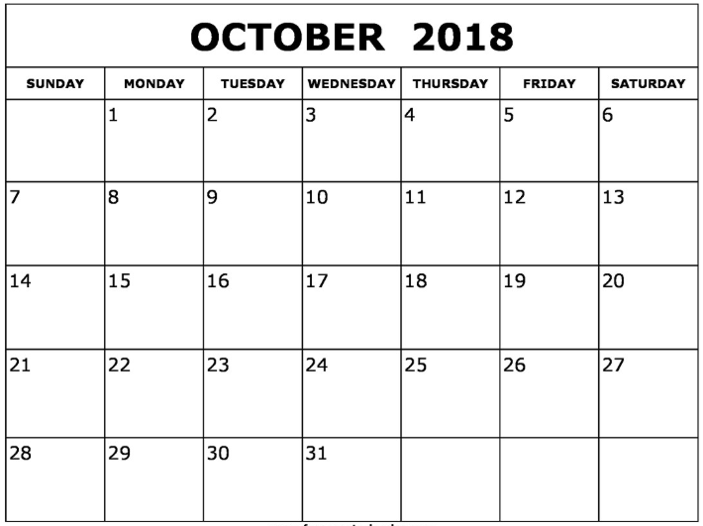

Find things around your home that are made of or come from trees. List three of them here.

1. _____________________ 2. _____________________ 3. _____________________

Circle the letters your child can name quickly.
s m r t g f v b k d c p w n h k l a e z x i j o q u y g a

Write your numbers to 10.

Ask your child what they did during literacy stations today.

Circle the letters your child can name quickly.
T V R G E I X S N D M Q L Y C U J O H B Z W P K F A
Students must know all capital and lower case letters by the end of the month.

Color the words your child can read quickly without help.
like | my | the | see
at | me | to | come
and | we | a | I

Word families are words that end with the same ending. We are making new words by changing the first letter. Ask your child what words are in the:

---at word family. (cat, bat, fat, hat, mat, Nat, pat, rat, sat, vat)

---an word family (ban, can, fan, man, Nan, pan, ran, tan, van)

Write how high your child can count. ___________ Count by 10s? ___________

Attend your child’s Parent-Teacher Conference!

Ideas for learning letters
Concentration – If you have two sets of cards (or if you make another set) you can play concentration. Choose several pairs of matching letters and spread them out face down on the floor/table. As the child turns over each letter, they must tell you what it is. If they match, he/she wins them. If they don’t, you must turn them back over

Sort magnetic letters
It sounds so very simple, but sorting magnetic letters really helps kids to focus on how letters are alike, how they’re different, and what shapes they are comprised of. Ideas on how to sort the letters — by color, uppercase versus lowercase, letters with holes versus letters without holes, letters with straight lines versus letters without straight lines, etc.

Due: Wednesday, November 1st

